**Table of Contents**

1. Article Summary 2
2. Introduction 2
3. Article Analysis 2
   1. Demand and Supply 2
   2. Economic Efficiency 6
4. Conclusions 8
5. References 9
6. **Article Summary**

In the article “Study Explores The Impact Of Uber On The Taxi Industry” (Gaskell, 2017), Gaskell discusses a study by Berger, Chen and Frey (2017), which looks at the impact of the introduction of Uber, a ride sharing platform on the taxi economy. Berger, Chen and Frey (2017) suggest that as opposed to the general opinion that Uber would negatively effect the taxi economy, significantly decreasing incomes and employment of traditional taxi drivers, Uber has only marginally effected their income, and employment has increased for both Uber drivers and traditional taxi drivers due to an increase in demand for point to point transport in general since the arrival of Uber.

1. **Introduction**

This essay will be exploring the micro-economic effects of the introduction of Uber – a ride sharing company, on the economy of point-to-point transport and the traditional taxi service as discussed in the article “Study Explores The Impact Of Uber On The Taxi Industry” (Gaskell, 2017). The essay will explain how demand and supply have changed in the industry, and then it will discuss how these changes have affected market equilibrium and economic efficiency, and discuss whether it has been a positive change in the point-to-point transport industry.

1. **Article Analysis**
   1. **Demand and Supply**

Demand and supply explains how demand and supply of a product interacts with price (Brennan, 2017(a)). I will be looking at how the introduction of Uber has changed the demand and supply of taxis.

The demand curve also called the “Willingness To Pay” curve, represents how many people are willing to pay a particular price for a product, such that if the price of a product is low, more people will be willing to purchase the product, however as price increases, less people will be “willing and able” to pay that price for that product (Brennan, 2017(a)). This is represented in diagram 1.0.

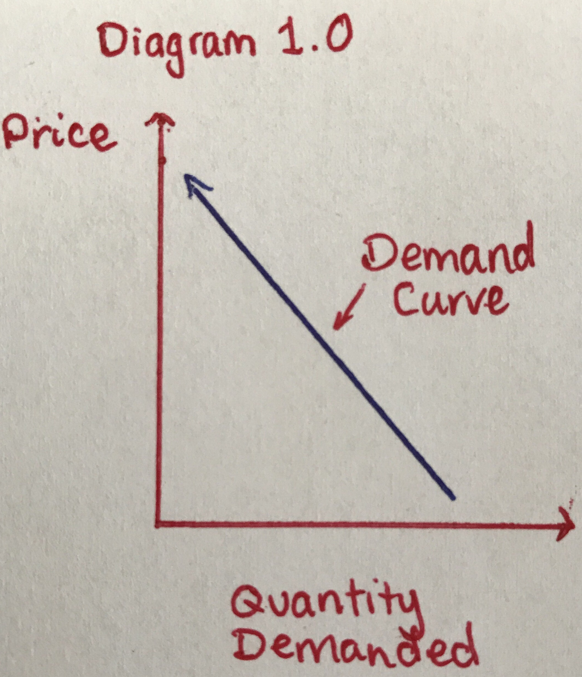

There are multiple factors beyond price that can affect demand by causing a shift of the demand curve, such as a price decrease in increase of a related good. Taxi’s and Uber are related goods, as they both services within the point to point transport industry, being that they “can used in place” of each other, they are what are called substitutes, and when the price of a substitute goes down, the demand for the product you are looking at, will decrease as people will choose the cheaper substitute (Brennan, 2017(a)). This is what people assumed would occur (Gaskell, 2017) to the demand of taxi services with the on average 20% cheaper Uber (Deloitte, 2016) entering the market as a substitute for taxis, the expected change is demonstrated in diagram 1.1.

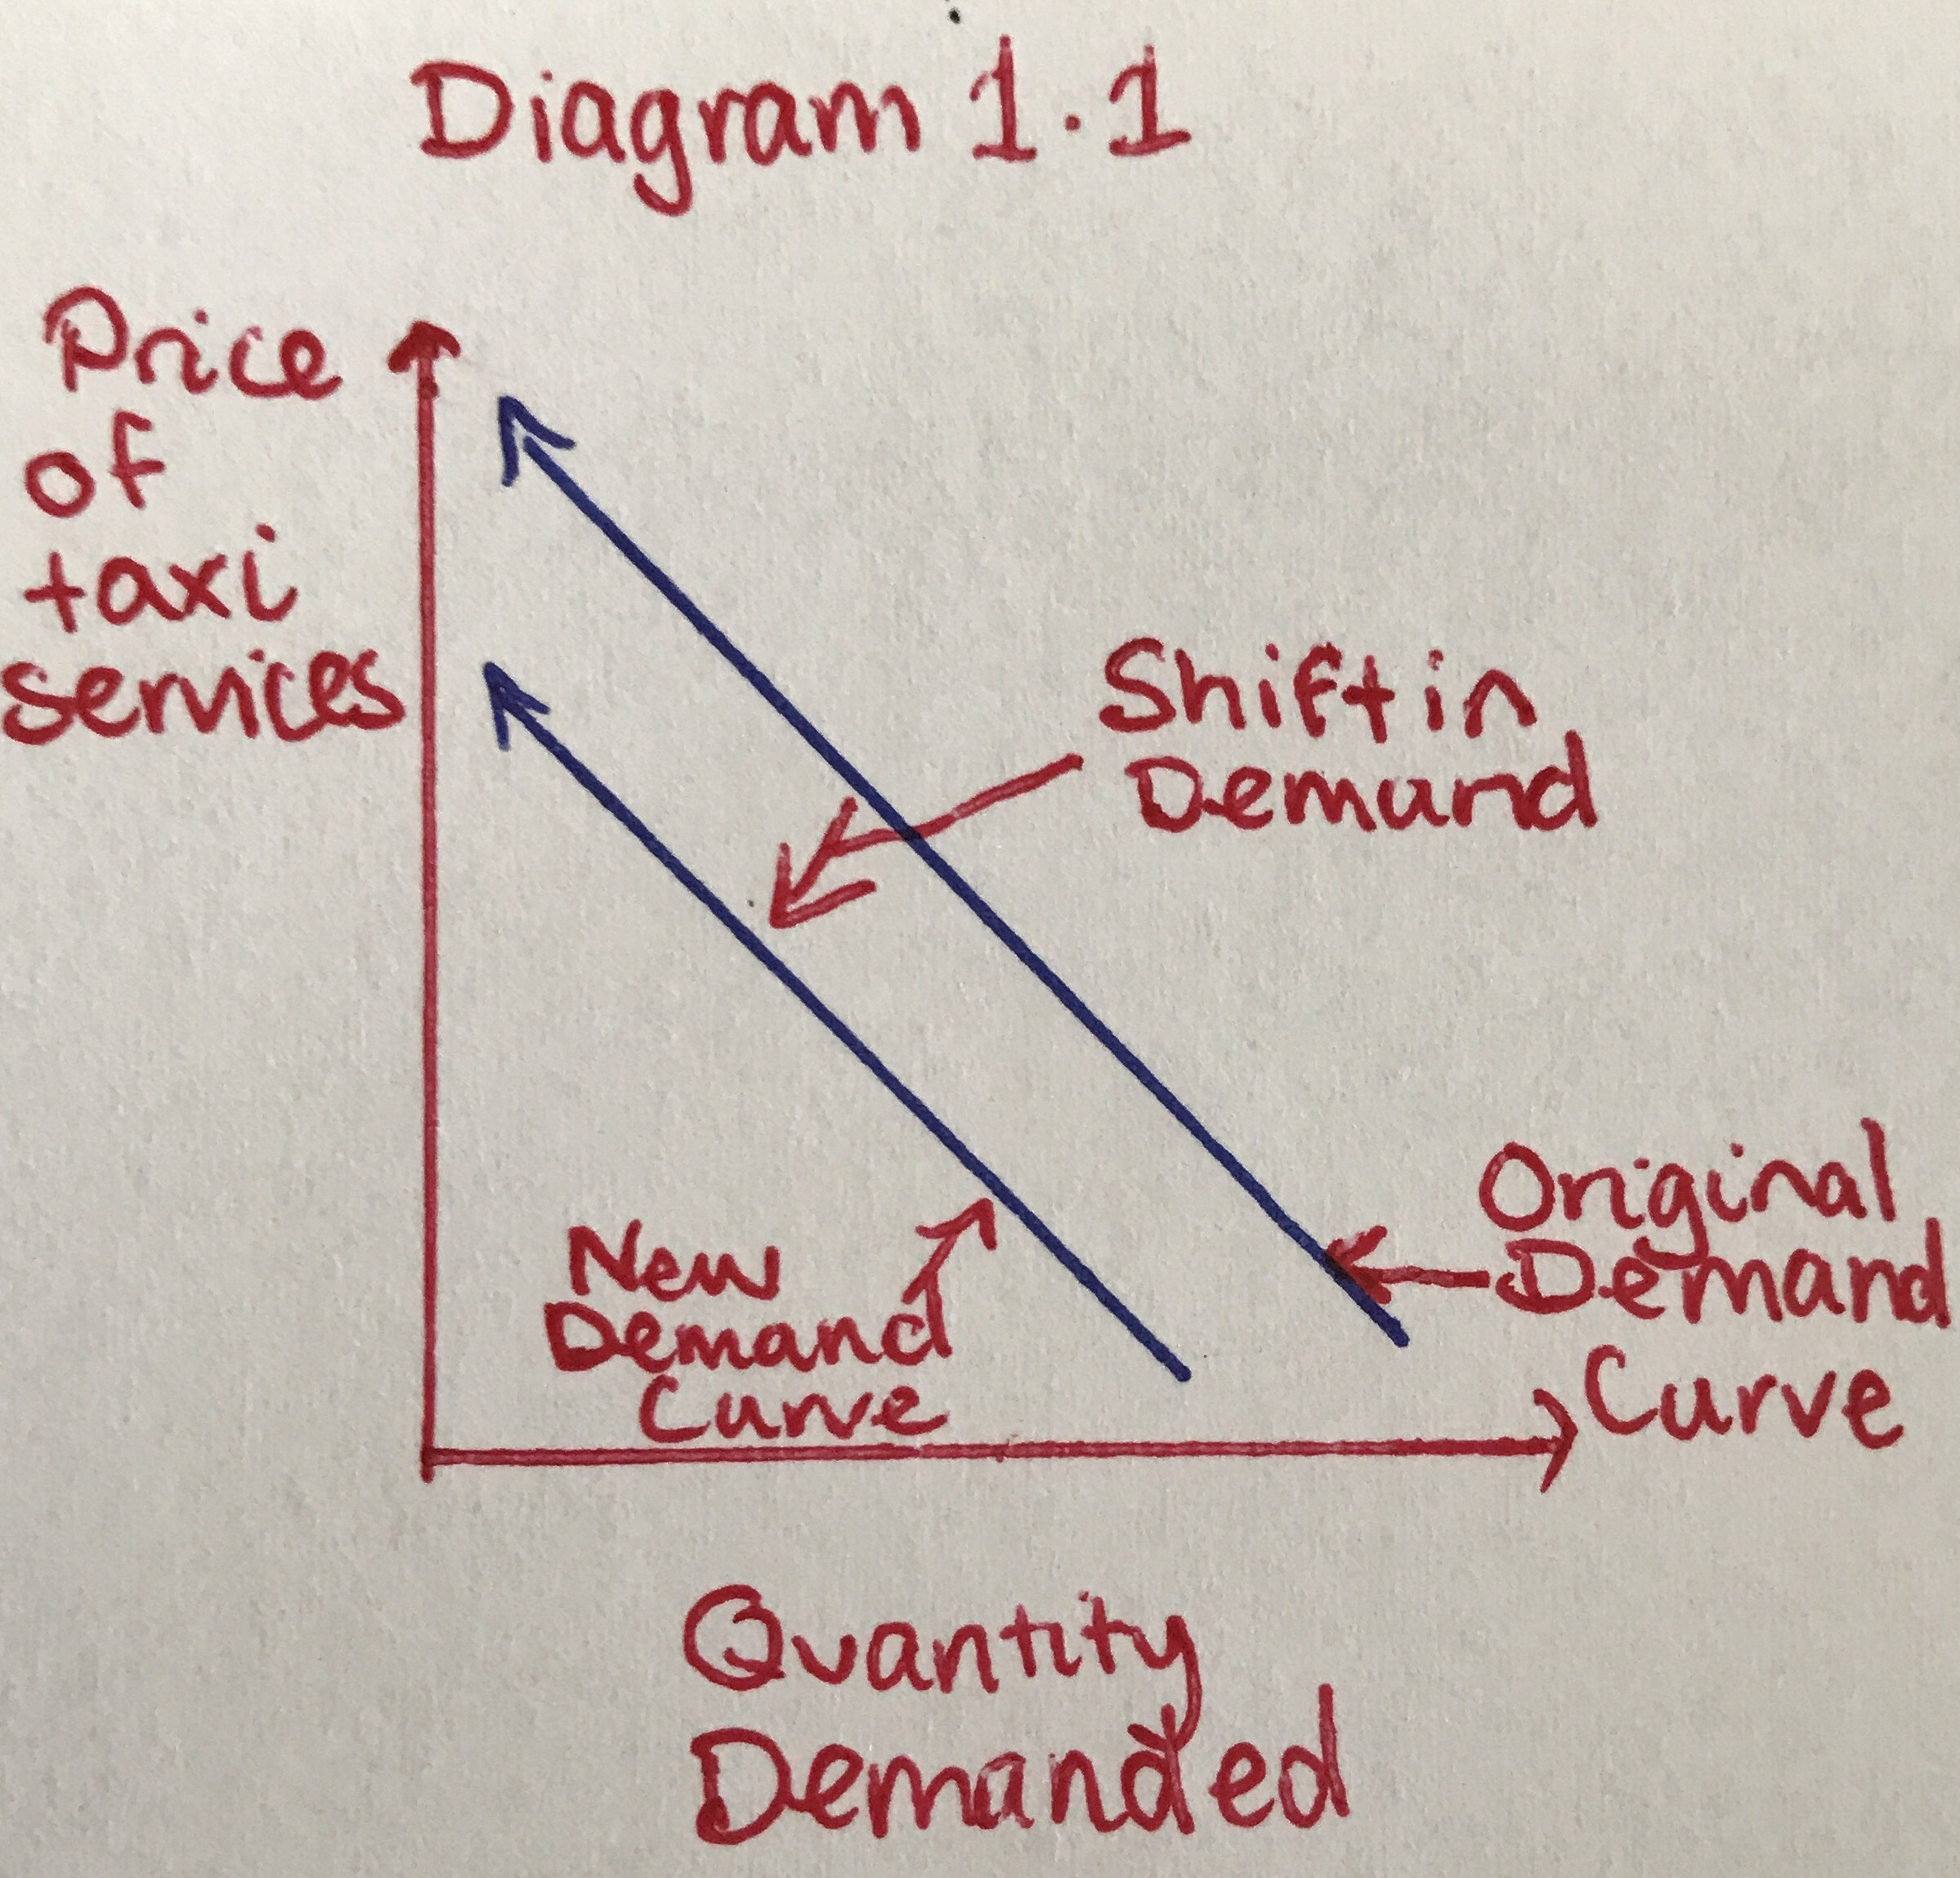

Another factor that can shift the demand curve is population and demographics (Brennan, 2017(a)). There has been an increase in demand of point-to-point transport in general since the introduction of Uber, extending to an increase in demand for taxis as well (Power, 2016). This shift is demonstrated in diagram 1.2. In the article by Power (2016) an representative from Uber said that “ridesharing does not capture markets, it creates them”, suggesting the general increase in demand for point to point transport is as a result of the introduction of Uber capturing the demand of an increased demographic.

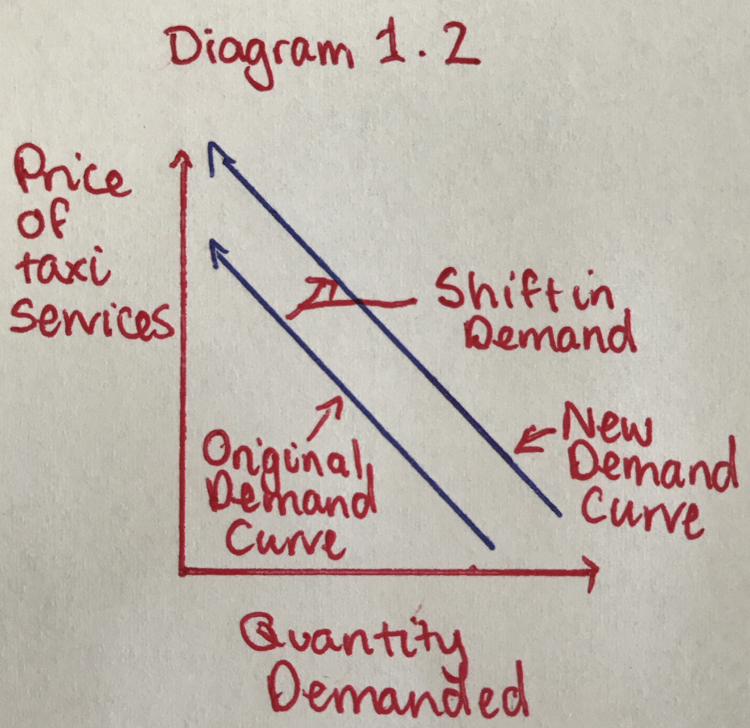

The other side to microeconomics is supply. The supply curve also called the “Willingness To Sell” curve, represents how much of a product or service suppliers are willing to supply at a particular price for that products or service, such that if a supplier is only able to sell their product or service at a low price, they will be less willing to supply more of that product or service, however, if they are able to sell it for a higher price, they are willing to supply more of it (Brennan, 2017(a)). This is represented in diagram 2.0.

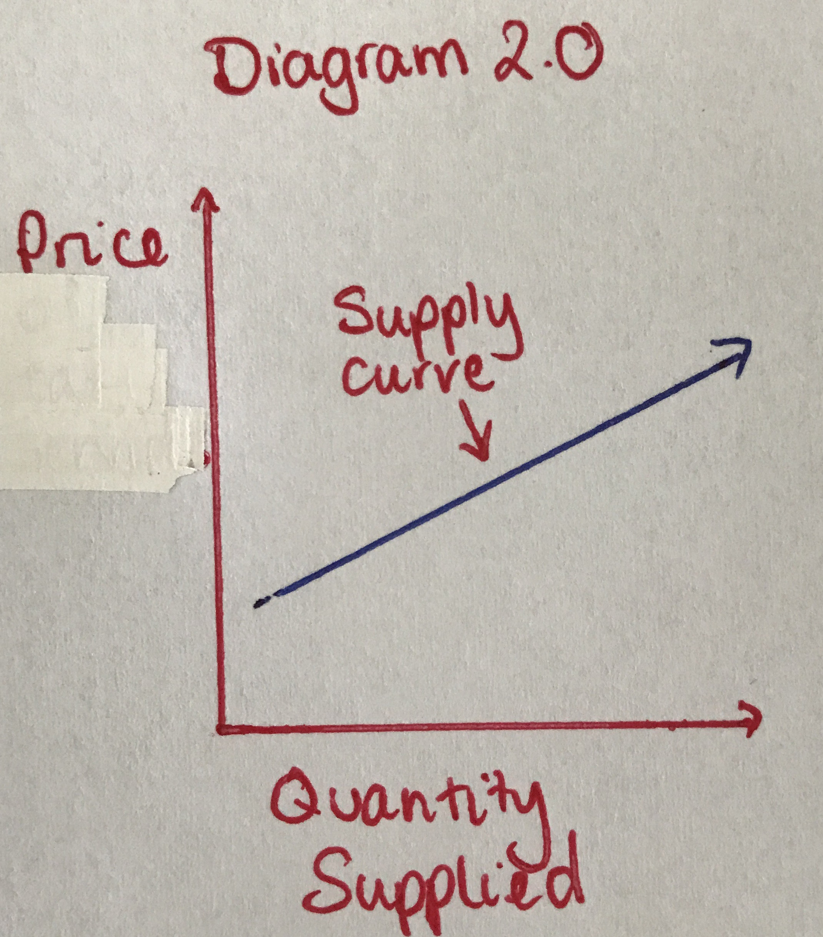

Similar to demand, there are multiple factors that can affect how much of a product or service is supplied, beyond price by causing a shift in the supply curve, such as an increase in the number of firms (Brennan, 2017(a)). In the case of the point to point transport industry, the introduction of Uber meant an increase in supply of point to point transport, however since then, there has been an increase in the number of drivers for both taxis and Uber with a “10% increase in salaried drivers” and a “50% rise in the number of self-employed drivers in a city” (Gaskell, 2017). This shift is represented in diagram 2.1.

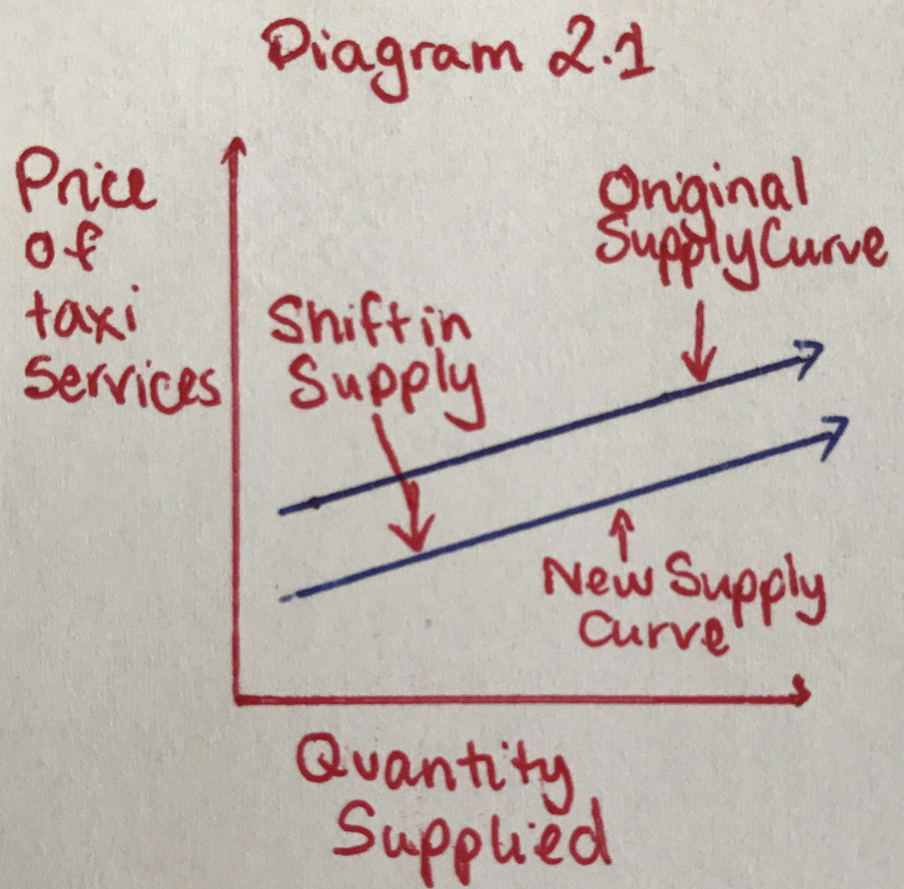

The ideal price for a product or service is at the market equilibrium, which occurs at the point where the supply and demand curves meet, or “when the price balances the plans of buyers and sellers” (Brennan, 2017(a)). This is demonstrated in diagram 3.0. Market equilibrium is a great way to look at the interaction between demand and supply, and how that interaction affects what the ideal price of a product or service should be in a changing market.

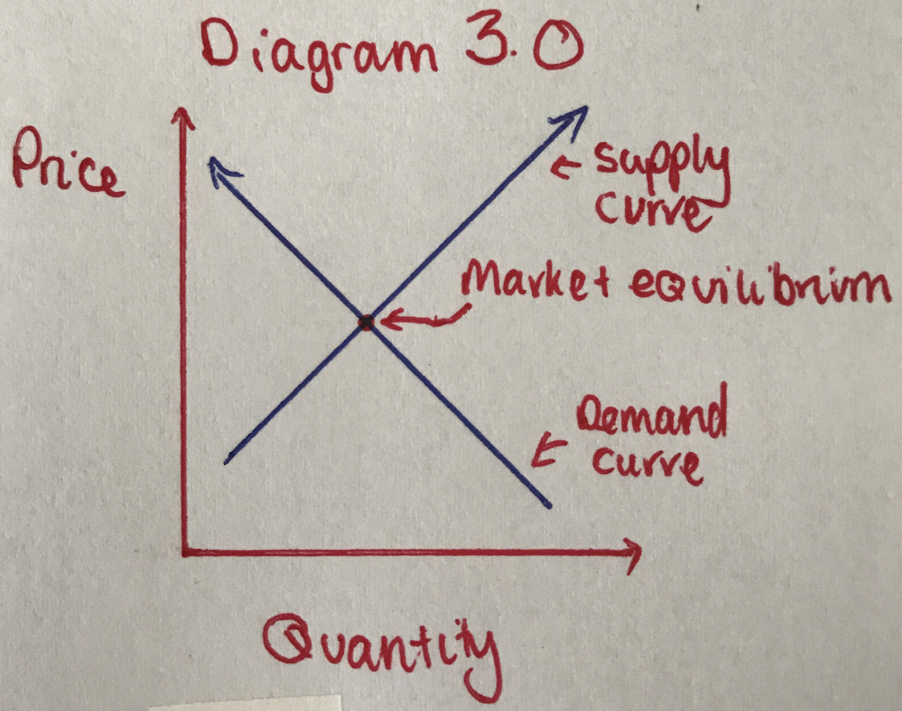

In the point to point transport market, we have discussed how the introduction of Uber was expected to decrease the demand of taxi’s (Gaskell, 2017) due to the on average cheaper (Deloitte, 2016) substitute entering the market, prices of taxi’s were in turn expected to lower the prices of taxis due to this demand curve shift, to keep competitive with Uber, or lead to a decrease in the number of taxi drivers employed, so that there isn’t a surplus of taxi drivers with the decreased demand. This is demonstrated in diagram 3.1, point A shows the original market equilibrium, point B shows the new equilibrium if supply of taxi drivers did not change with the decrease in demand, and point C shows the new equilibrium if supply was of taxi drivers shifted with the decrease in demand as they let go of taxi drivers.

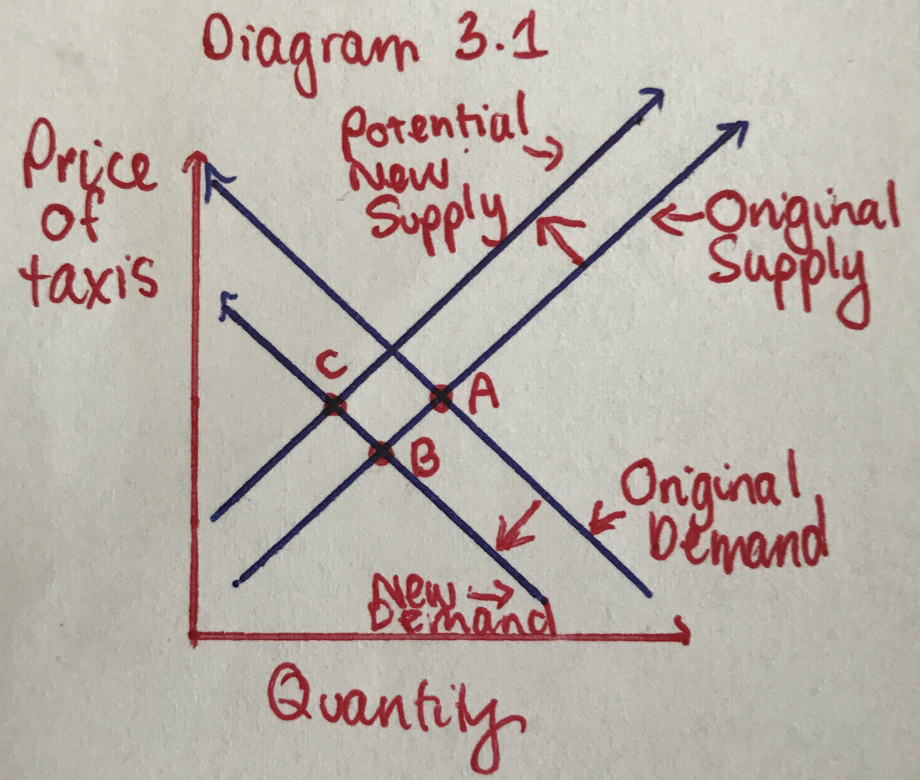

This did not occur however, as the introduction of Uber increased the demand for point to point transport in general, and therefore increased the demand for taxi’s as well, which rather than leading to an increase in the price of taxi’s lead to an increase in the number of taxi driver’s employed, and therefore the supply of taxi’s was increased, maintaining the same price, as shown in diagram 3.2, point A shows the original market equilibrium, and point B shows the new market equilibrium with the increase in demand and supply that occurred.

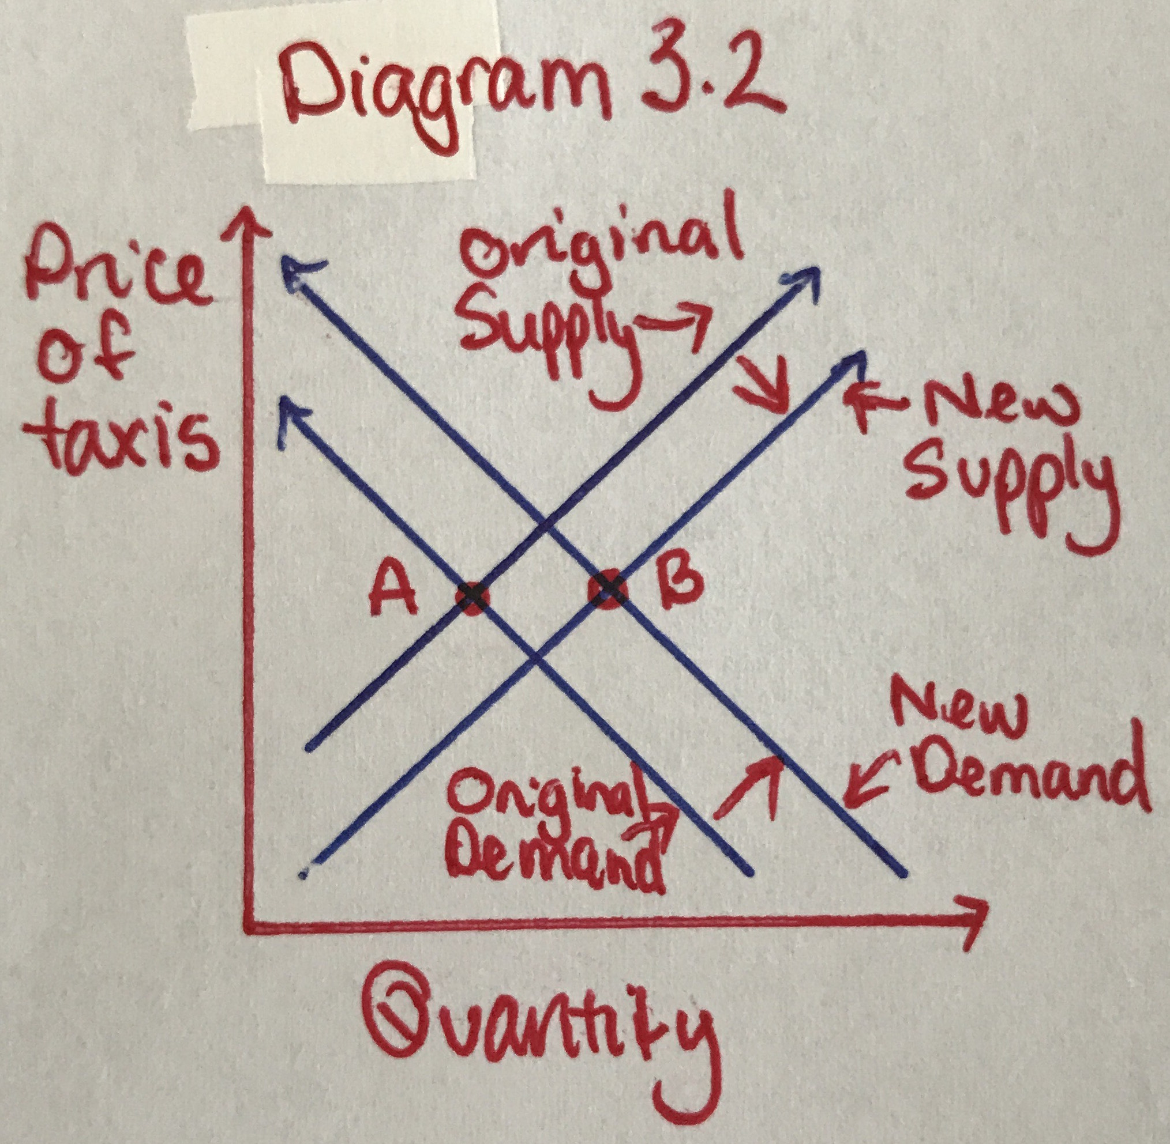

* 1. **Economic Efficiency**

Economic efficiency looks at the benefit or “welfare” that producers and suppliers receive from the current state of a market, and how this is affected by a change in the market (Brennan, 2017(b)). I will be exploring the concepts of consumer and producer surplus to look at the benefit or detriment of the introduction of Uber into the point-to-point transport market for consumers, and taxi drivers.

Consumer surplus is the “net benefit when you purchase something” which is the difference between what you would have been willing to pay for a product or service, and what you actually paid (Brennan, 2017(b)). This is represented in diagram 4.0 as the yellow shaded area.

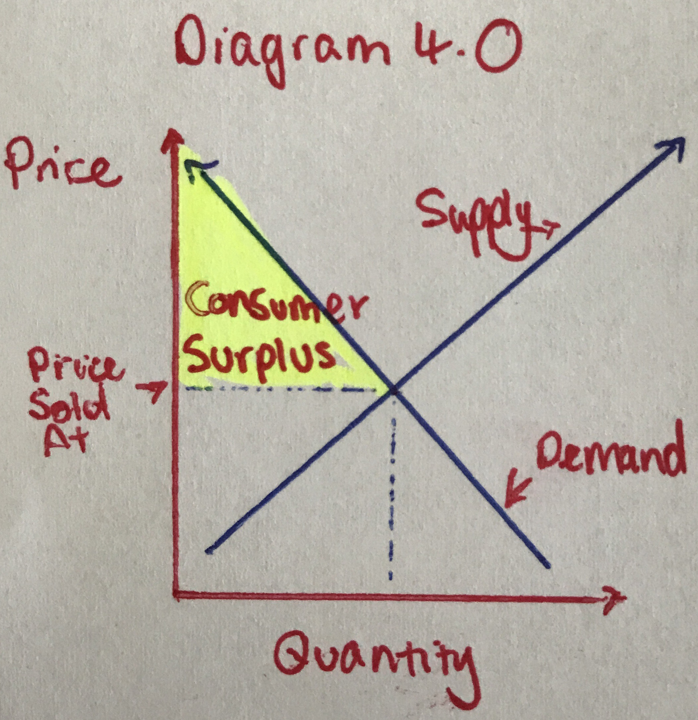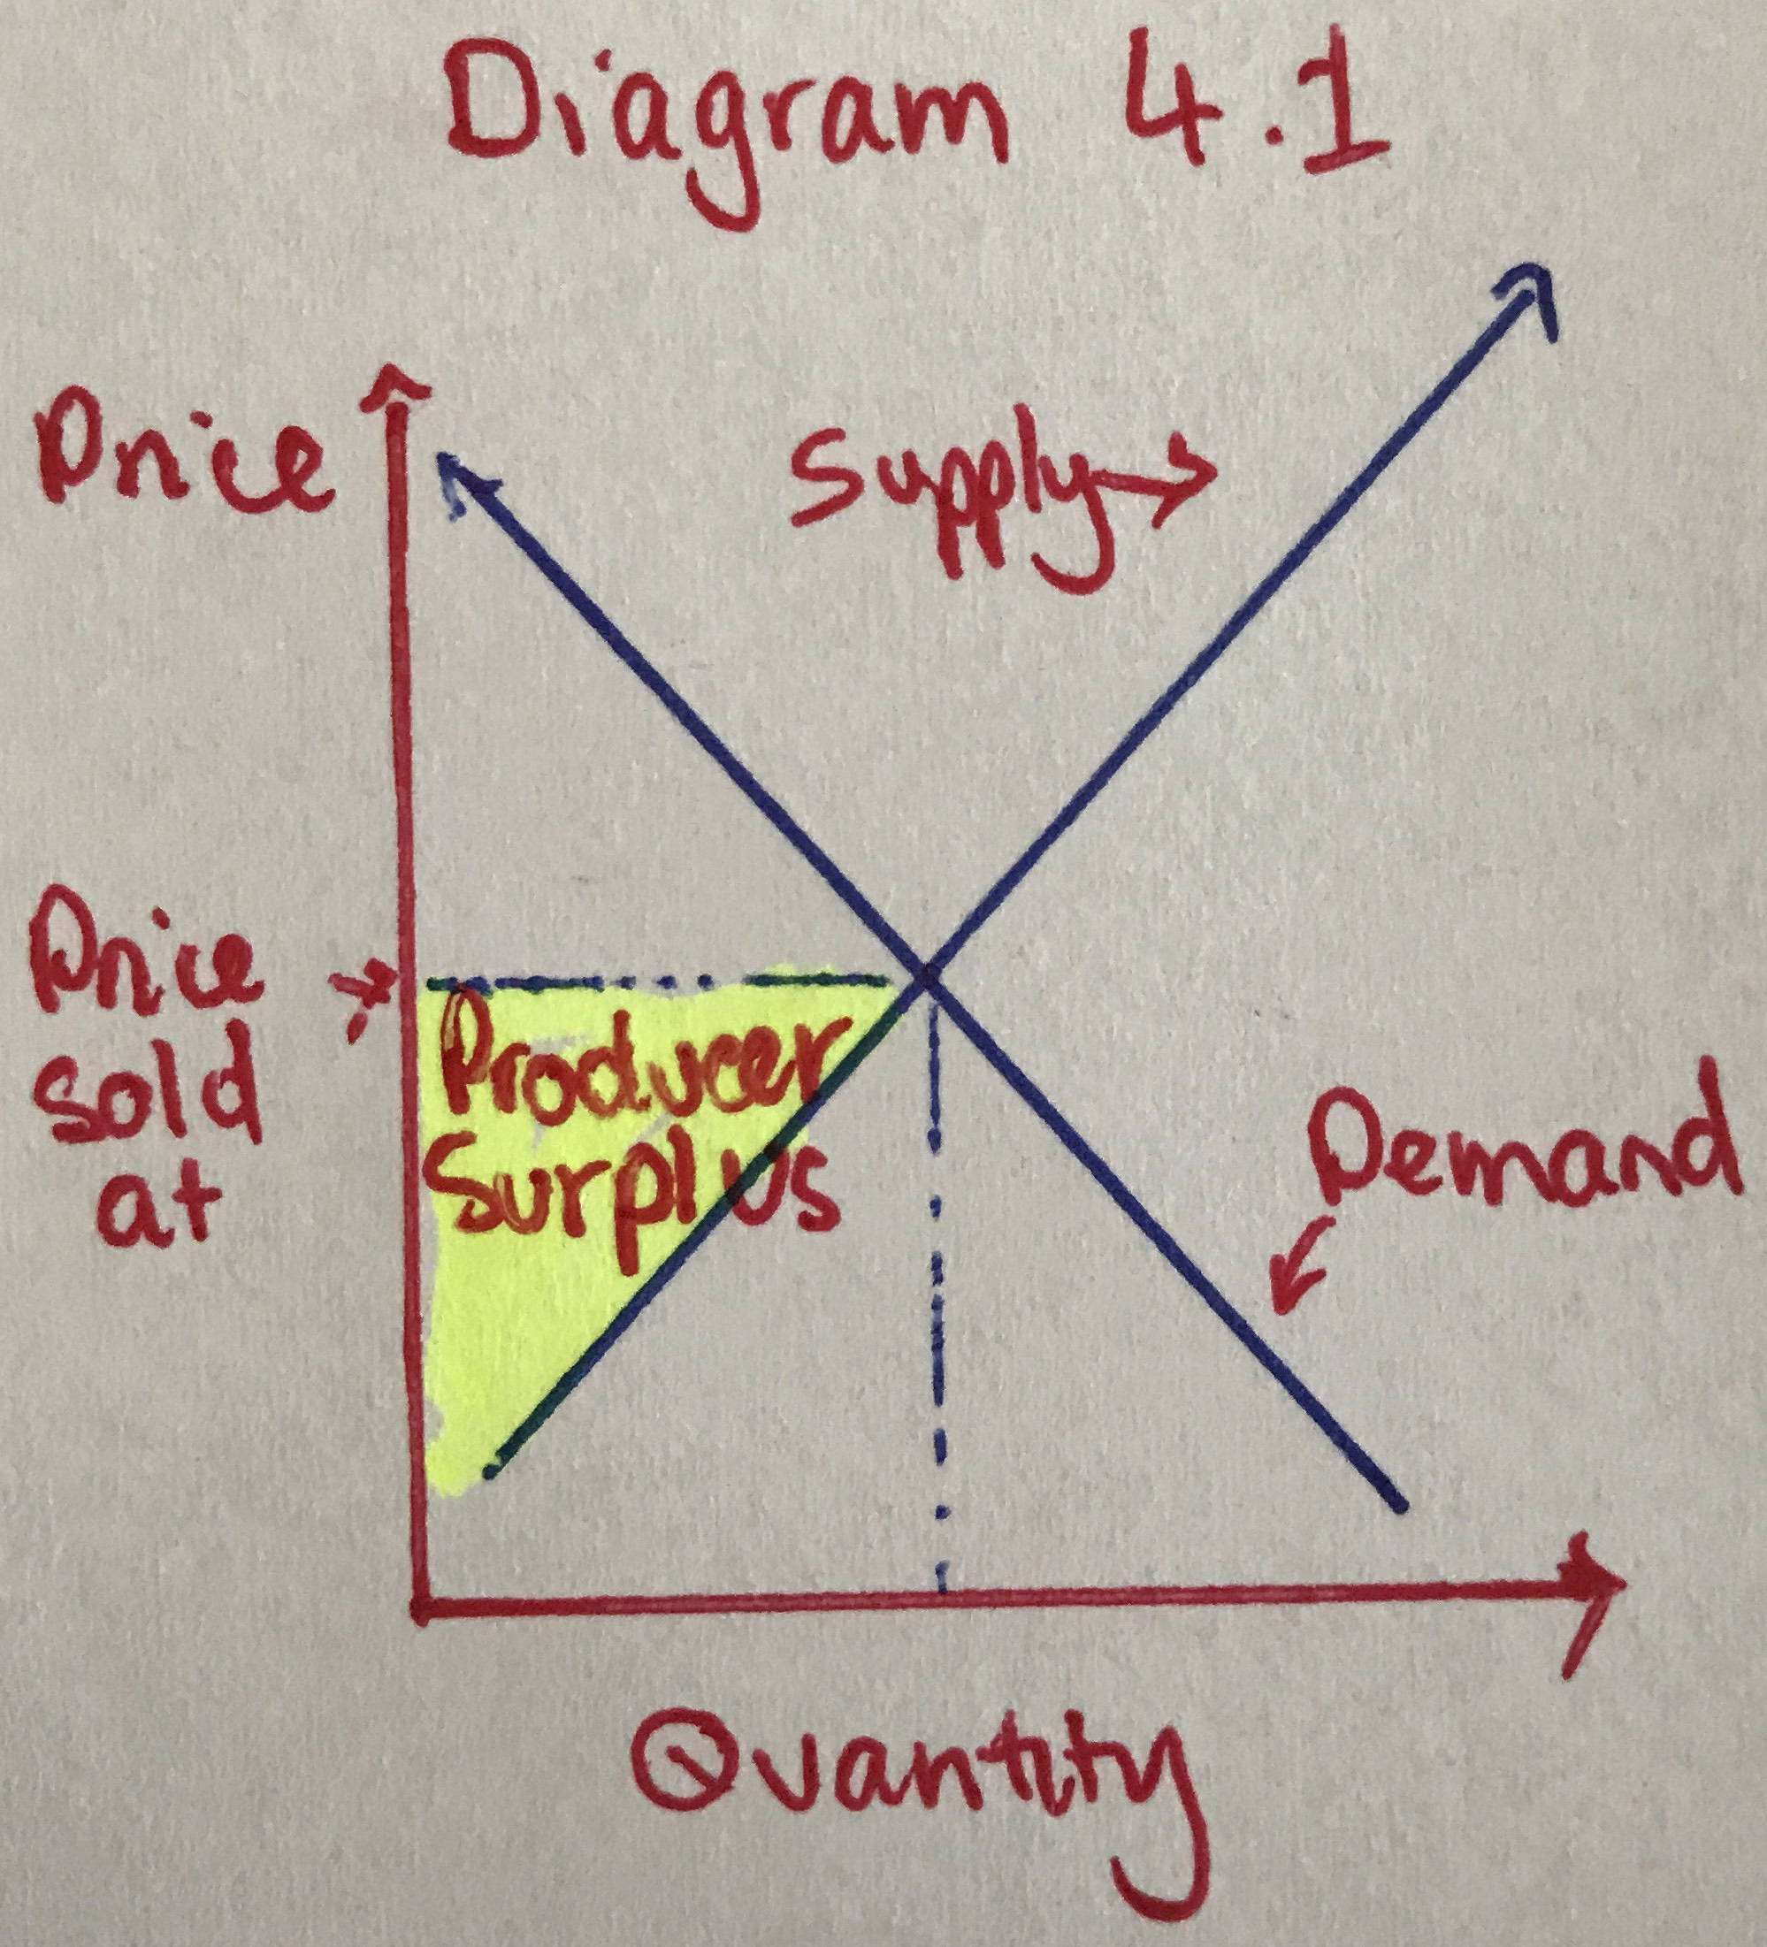

Producer surplus is the “net benefit when a producer sells something” which is the difference between what a supplier would have been willing to sell a product or service for, and what they actually sold it for (Brennan, 2017(b)). This is represented in diagram 4.1 as the yellow shaded area.

The expectation was that demand for taxi’s would decrease, and therefore to maintain price, taxi drivers would be let go, leading to a decrease in taxi’s supplied, this is demonstrated in diagram 5.0, with point A the original market equilibrium and point B the new equilibrium. The original consumer surplus was the orange and yellow shaded areas added together, however the new consumer surplus is only the orange shaded area, with a loss in surplus equal to the yellow shaded area. The original producer surplus was the blue and green shaded areas added together, and the new producer surplus is only the blue shaded area, with a loss in producer surplus of the green shaded area. What this loss means is there is a decrease in happiness with the price of the service for consumers, and a loss of revenue for the producer.

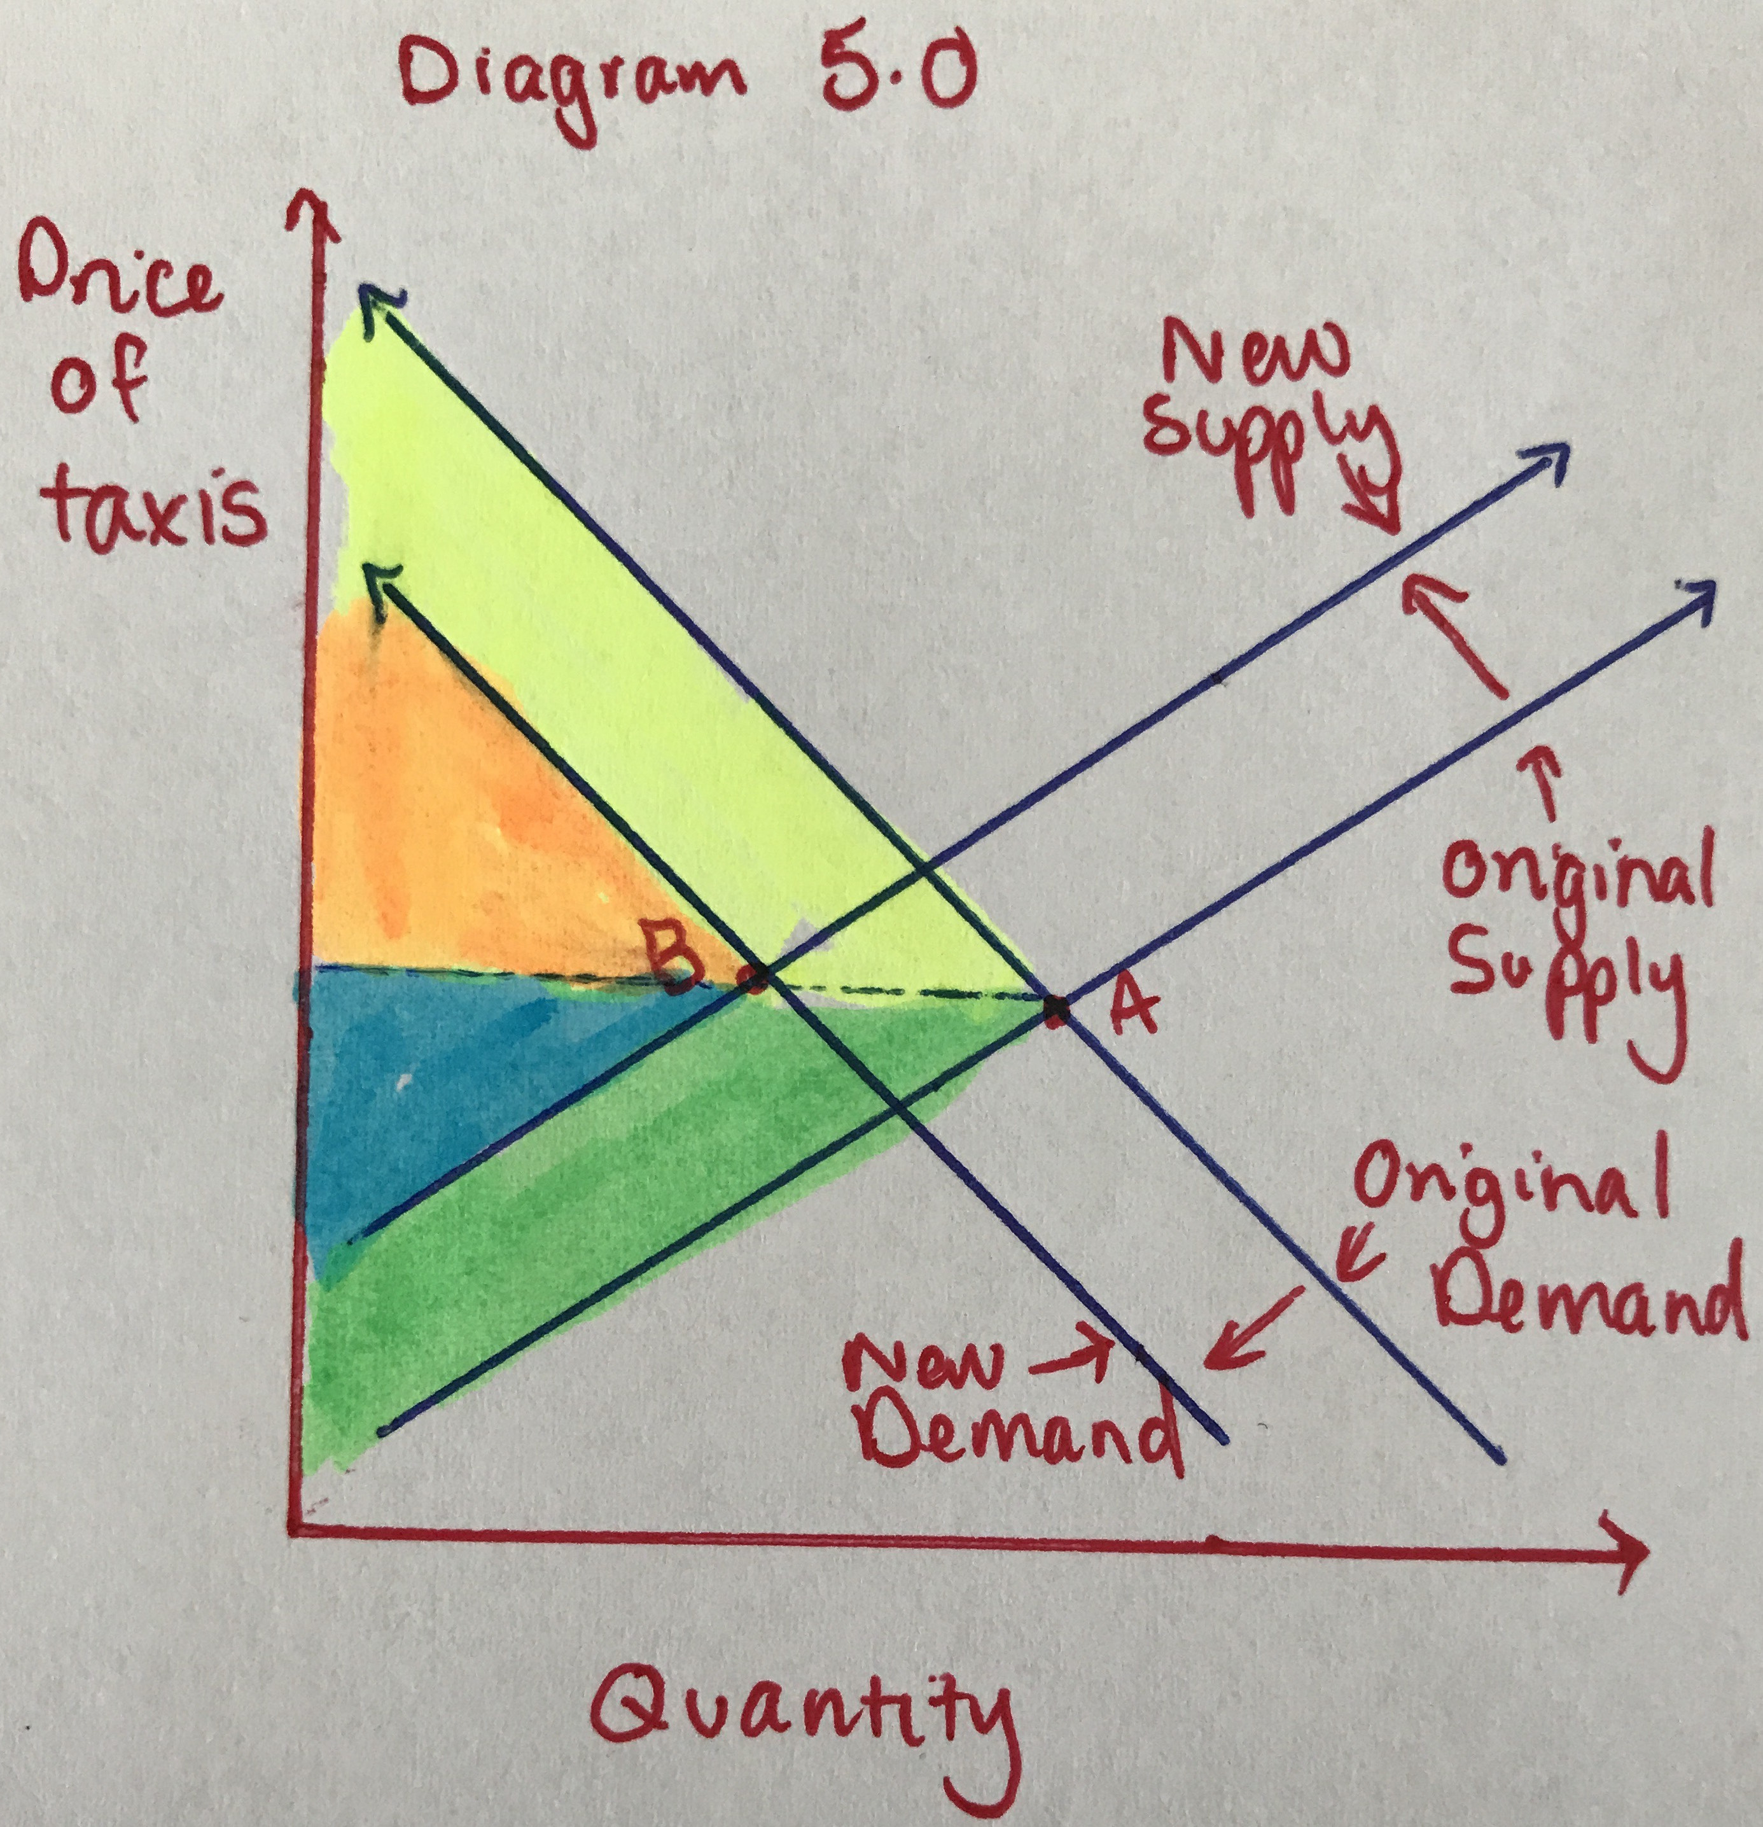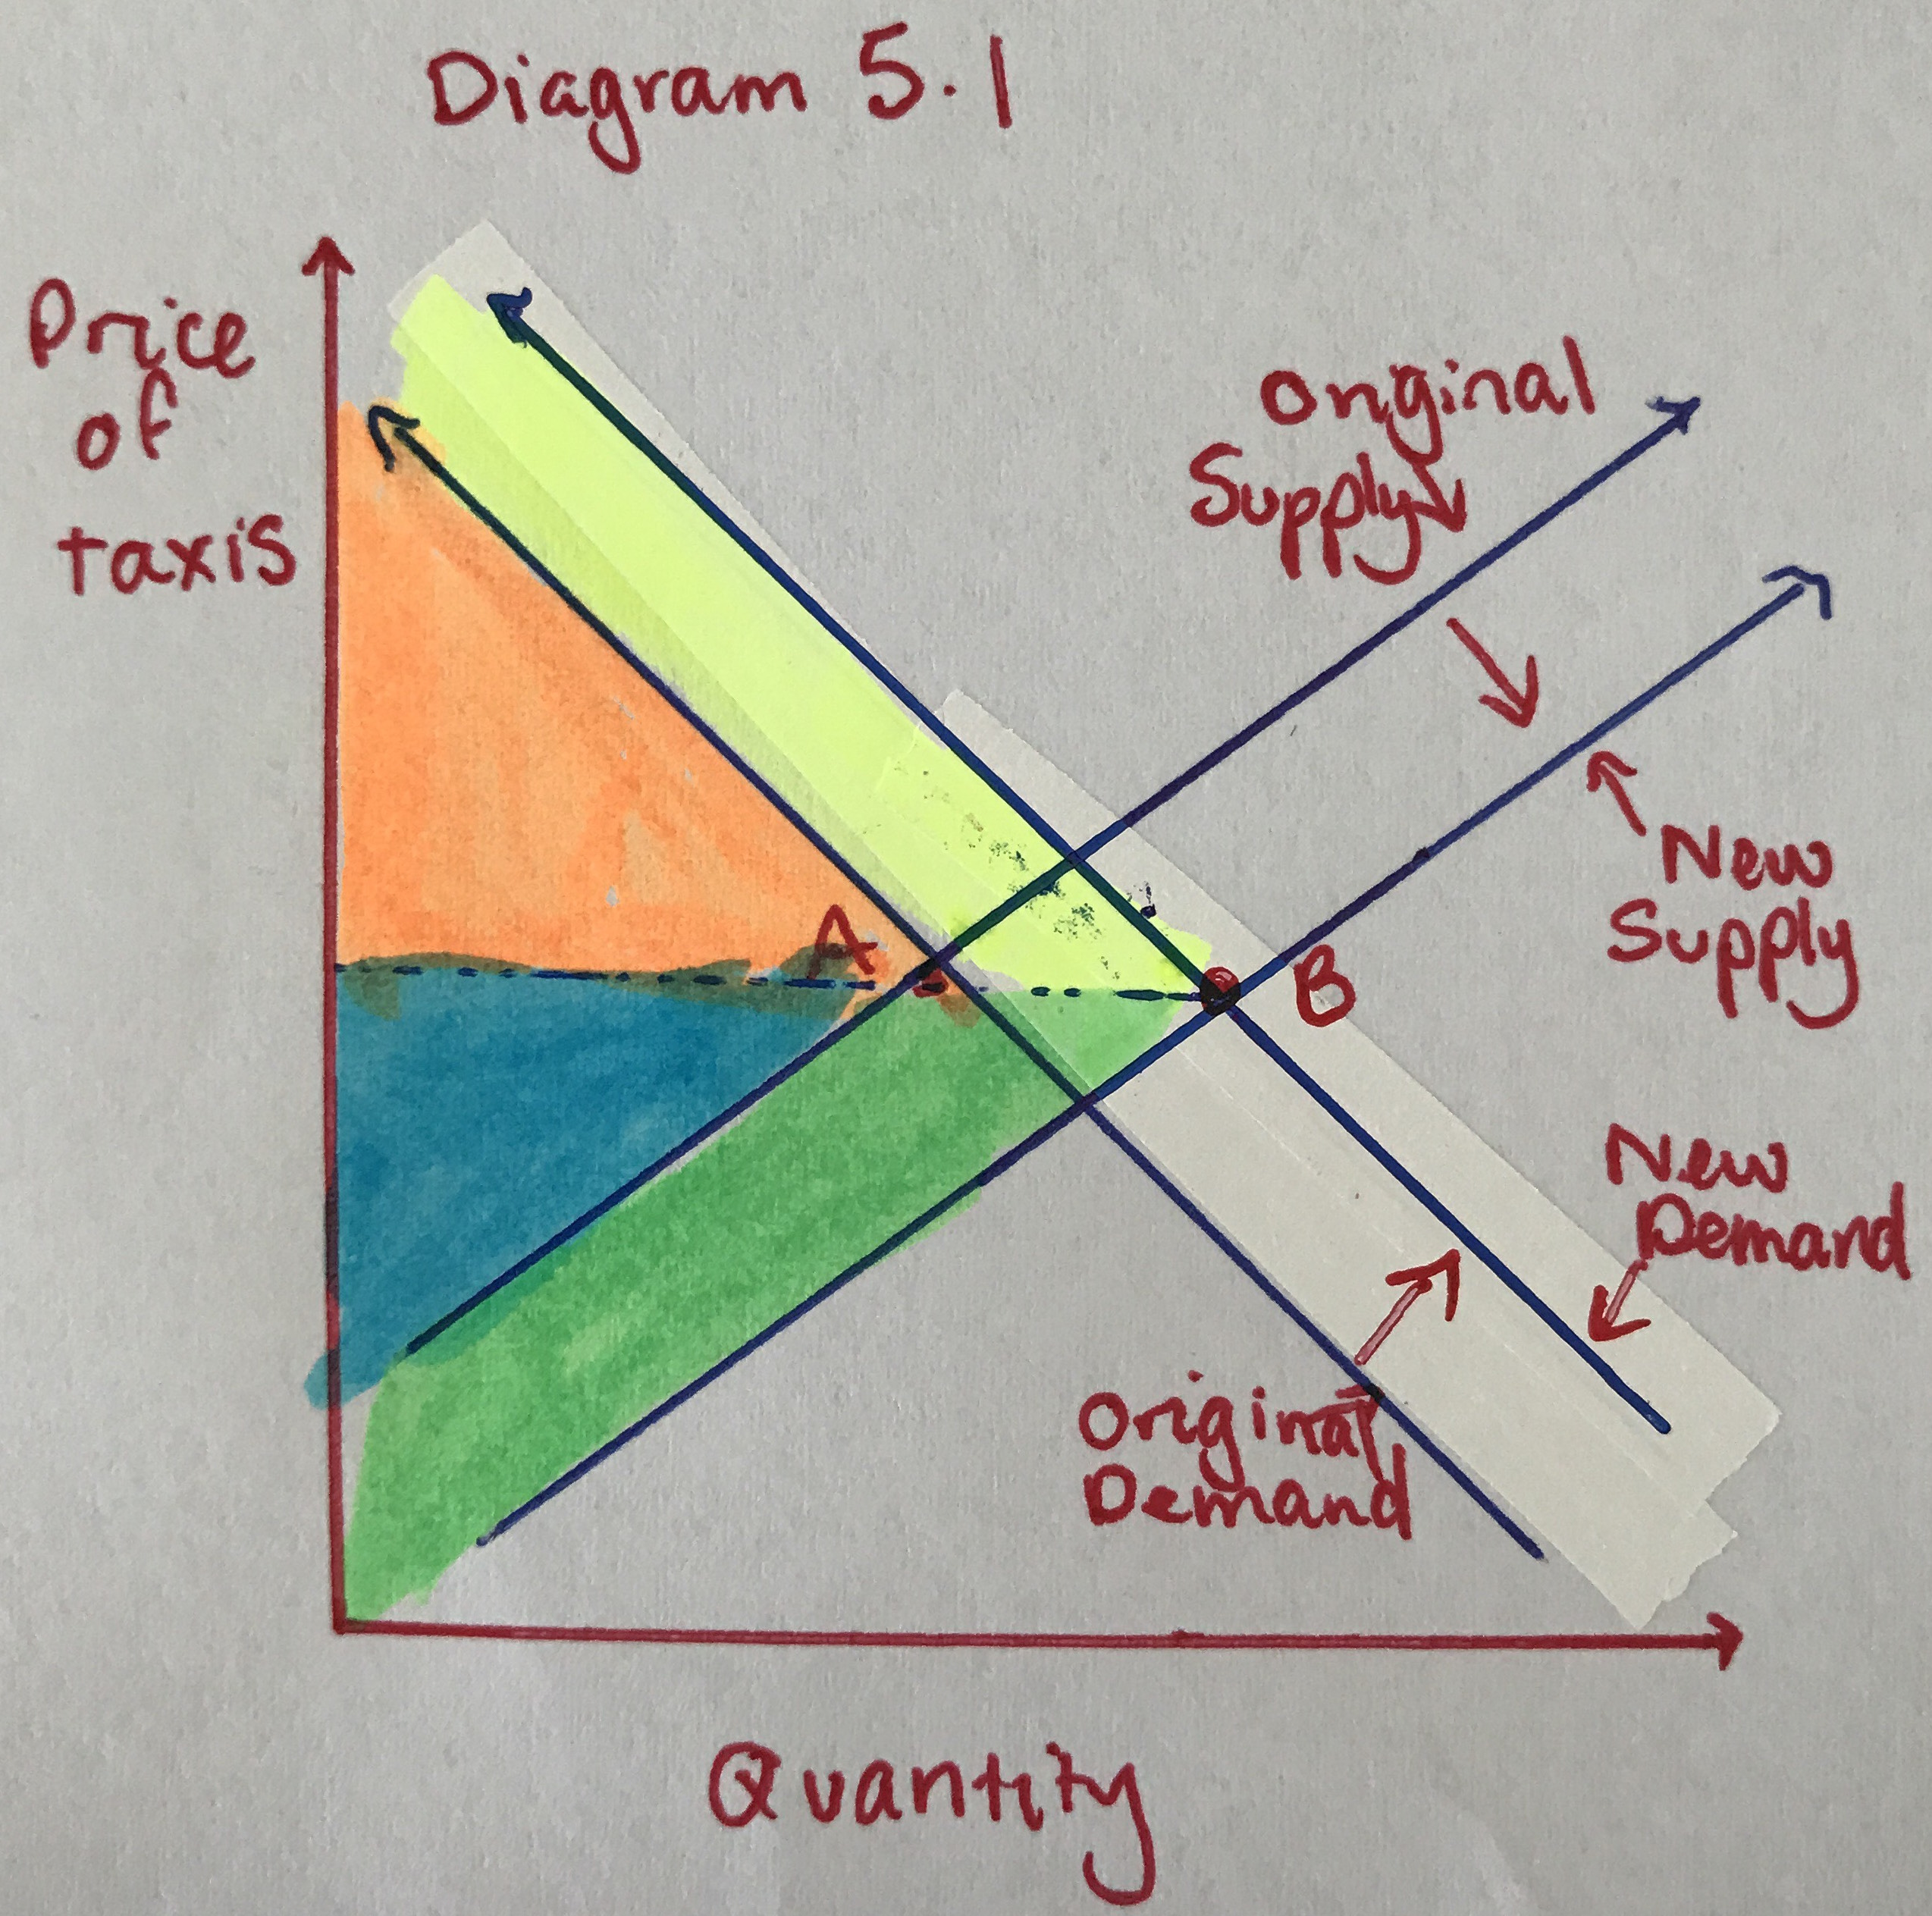

What actually occurred was that demand and supply for taxi’s increased. This is demonstrated in diagram 5.1, with point A the original market equilibrium and point B the new market equilibrium. The original consumer surplus was the orange shaded area, and the new consumer surplus is the yellow and orange shaded areas added together, with an increase in consumer surplus equal to the yellow shaded area. The original producer surplus was the blue shaded area, and the new producer surplus is the blue and green shaded areas added together, with an increase in producer surplus equal to the green shaded area. What this gain means, is there is an increase in happiness with the price of the service for consumers and a gain in revenue for the producer.

1. **Conclusions**

On the surface this seems like it has been a positive change for everyone, however the diagrams are only representative and not a true representation of the proportions of the change in supply and demand. In reality, demand for taxi’s has only increased approximately 5% (Deloitte, 2016), while the increase in the number of Uber drivers has been 50% with an additional small increase in the number of taxi drivers (Gaskell, 2017), which means an increase in revenue still for the taxi companies in general however, as there are significantly more drivers, with only a small gain in demand, the amount of revenue is split amongst significantly more people, and therefore has lead to a 10% salary decrease for the taxi drivers (Gaskell, 2017).

In summation, Uber has been a positive influence on the point-to-point transport industry as a whole, and has increased the revenue for taxi companies, however these benefits have not filtered down to the taxi drivers themselves, who are facing significant losses. Fortunately changes to the cost of taxi plates is decreasing and other measures are being put in place to rectify this, as the gain in employment and revenue in the point to point transport industry is too great to not have Uber a part of the industry.

1. **References**

Berger, Chen and Frey. 2017. “Drivers of Disruption? Estimating the Uber Effect*”.  *Oxford Martin.* January 17.

<http://www.oxfordmartin.ox.ac.uk/downloads/academic/Uber_Drivers_of_Disruption.pdf>

Brennan, Andrew. 2017 (a). “Lecture 2: Demand and Supply” PowerPoint lecture notes.

<https://lms.curtin.edu.au/bbcswebdav/pid-4533129-dt-content-rid-25262034_1/xid-25262034_1>

Brennan, Andrew. 2017 (b). “Lecture 4: Economic Equilibrium” PowerPoint lecture notes.

<https://lms.curtin.edu.au/bbcswebdav/pid-4533151-dt-content-rid-25307983_1/xid-25307983_1>

Deloitte. 2016. “Economic effects of ridesharing in Australia”. *Deloitte*. 2017.

[https://www2.deloitte.com/au/en/pages/economics/articles/economic-effects-ridesharing-australia-uber.html#](https://www2.deloitte.com/au/en/pages/economics/articles/economic-effects-ridesharing-australia-uber.html)

Gaskell, Adi. 2017. “Study Explores The Impact Of Uber On The Taxi Industry.” *Forbes.* January 17.

<https://www.forbes.com/sites/adigaskell/2017/01/26/study-explores-the-impact-of-uber-on-the-taxi-industry/#29c4627716b0>

Power, 2016. “$1 fee on all taxi and Uber trips in pipeline to compensate drivers, despite industry surge.” *Sydney Morning Herald.* June 17.

<http://www.smh.com.au/nsw/1-fee-on-all-taxi-and-uber-trips-in-pipeline-to-compensate-drivers-despite-industry-surge-20160616-gpl4ue.html>

